HK INSTITUTE OF VOCATIONAL EDUCATION
DEPARTMENT OF INFORMATION AND COMMUNICATIONS TECHNOLOGY

ITP4910 Software Development Project

LAB 06 – Database Management Basics

Objectives:
- To connect Access Database, and view the table data in the Server Explorer.
- To access a database with a DataTable object.
- To bind some basic controls to the DataTable object to display data.
- To display data using the DataGridView control
- To change the contents of a database

Part A Adding a connection to a database and view the table data in the Server Explorer

Visual Studio 2008 has a tool called Server Explorer that allows a developer to browse through the contents of a database and information on another computer.

- Download the database ITP4910-Lab06-DB.zip.

- Create a new project of type Windows Applications. Enter Lab06 as its name.

- Unzip the lib.accdb database files and place them inside the Debug directory of your application.

- Open the Server Explorer from the View menu.

- Right-click on Data Connections and select Add connection.

- In the Add Connection dialog box that appears, clear the contents of the “User name” text box.

- In the Add Connection dialog box that appears, the Data Source should be “Microsoft Access Database File (OLEDB).” If not, click on the Change button, select “Microsoft Access Database File” as the data source, and click OK. Click on the “Browse … ” button to the right of the “Database file name” text box. Select the file lib.accdb from the debug folder of your application and press Open.

- Press the Test Connection button. The message “Test Connection Succeeded” will appear. Press the OK button on the message box and then press the OK button on the Add Connection box.

- An icon titled something like “lib.accdb" should appear in the Server Explorer. Click on the + sign to the left of the icon to expand the entry. Four subentries will appear: Tables, Views, Stored Procedures and Functions.

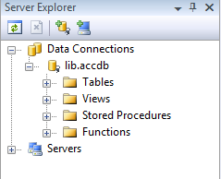

- Expand the Tables entry to reveal the three subentries Books, BorrowRecords, Users.

- Expand the Books entry to show the fields of the Books table.

- Right-click on Books and select “Retrieve Data”.
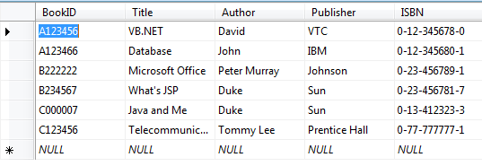

Hint: The connection for database in the Server Explorer can be removed by right-clicking on the entry and then selecting Delete.

Part B: Accessing a Database with a Data Table

A DataTable object holds the contents of a table as a rectangular array. You need to create a DataTable variable and fill it with the contents of a specific table in a database first.

- Create a new form with the following layout.

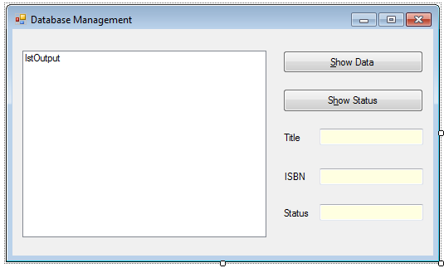

Properties Table

Object | Property | Setting
Form | Name  Text | Form1  Database Management
Label | Name  Text | lblTitle  Title
Label | Name  Text | lblISBN  ISBN
Label | Name  Text | lblStatus  Status
Text Box | Name  BackColor  ReadOnly | txtTitle  Info  True
Text Box | Name  BackColor  ReadOnly | txtISBN  Info  True
Text Box | Name  BackColor  ReadOnly | txtStatus  Info  True
Button | Name  Text | btnShow  &Show Data
Button | Name  Text | btnStatus  S&how Status
List Box | Name  Font | lstOutput  Courier New, 8.25pt

- Add the following using statement in the code window of Form1

using System.Data.OleDb;

- Declare and initiate a DataTable object dt and use the following code in the Form Load event to fill dt with data from the database through a DataAdapter object.

private DataTable dt = new DataTable();

private void Form1_Load(object sender, EventArgs e) {
string connStr = "Provider=Microsoft.ACE.OLEDB.12.0;"
+ "Data Source=lib.accdb";
string sqlStr = "Select * from Books";

OleDbDataAdapter dataAdapter =
new OleDbDataAdapter(sqlStr, connStr);
dataAdapter.Fill(dt);
dataAdapter.Dispose();
}

Hint :
- A DataTable object is the representation of a table (with rows and columns).
- A DataAdapter is an object that serves as a conduit to allow bidirectional data transfer between a database on a disk and a data table in memory.
- The variable connStr is called a connection string with two parameters Provider and Data Source. They are used to describe the type and name of the database.
- The variable sqlStr is called a SQL string telling the data adapter which table to retrieve.
- The value of dt.Rows.Count gives the number of records in the table.
- The value of dt.Columns.Count gives the number of fields in a record.
- The records are numbered 0 through dt.Rows.Count – 1 while the fields are numbered 0 through dt.Columns.Count – 1.
- A specific field of a specific record can be accessed by either dt.Rows(i)(j) or dt.Rows(i)(fieldname).
- If you want to use the Access 2003 database lib.mdb, the connection string should be changed to
string connStr = "Provider=Microsoft.Jet.OLEDB.4.0;"
+ "Data Source=lib.mdb"

- Add code for the event btnShow_Click

private void btnShow_Click(object sender, EventArgs e) {
string frmStr = "{0,-30}{1,-30}{2,-30}";
lstOutput.Items.Clear();
lstOutput.Items.Add(String.Format(frmStr, "Title",
"Author", "Publisher"));
for (int i=0; i<dt.Rows.Count; i++)
lstOutput.Items.Add(String.Format(frmStr, dt.Rows[i]["Title"],
dt.Rows[i]["Author"], dt.Rows[i]["Publisher"]));
}

- Run the program and click on the Show Data button to test it.

- Create a new Window Form as following:

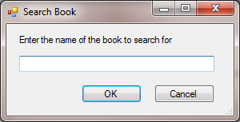
Properties Table

Object | Property | Setting
Form | Name  Text  AcceptButton  CancelButton | frmSearch  Search Book  btnOK  btnCancel
Label | Name  Text | lblTitle  Enter the name of the book to search for
Text Box | Name | txtTitle
Button | Name  Text  DialogResult | btnOK  OK  OK
Button | Name  Text  DialogResult | btnCancel  Cancel  Cancel

- Add code for the event btnOK_Click

public string Result { get; set; }

private void btnOK_Click(object sender, EventArgs e) {
Result = txtTitle.Text;
Close();
}

- In Form1, add code for the event btnStatus_Click

private void btnStatus_Click(object sender, EventArgs e) {
Boolean bookFound = false;

txtTitle.Clear();
txtISBN.Clear();
txtStatus.Clear();
frmSearch frm = new frmSearch();
DialogResult result = frm.ShowDialog();
if (result == DialogResult.OK) {
for (int i = 0; i < dt.Rows.Count; i++)
if (dt.Rows[i]["Title"].ToString().ToUpper().Equals(
frm.Result.ToUpper())) {
bookFound = true;
txtTitle.Text = dt.Rows[i]["Title"].ToString();
txtISBN.Text = dt.Rows[i]["ISBN"].ToString();
txtStatus.Text = dt.Rows[i]["Status"].ToString();
}
if (!bookFound)
MessageBox.Show("No such book can be found");
}
}
}

- Run the program and click on the Show Status button to test it.
Part C: Simple Binding of controls to the data table

A data table can be connected to a certain control and have information transformed automatically into the control. In such a situation, the control is said to be bound to the data table.

- Create a new form named Form2 with the following layout. When running your Form2, remember to change the start-up form to Form2.

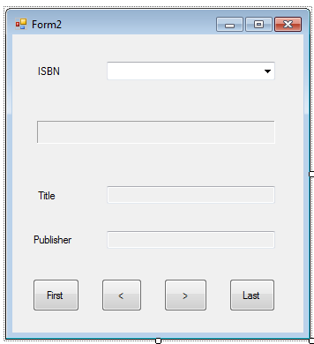

Properties Table

Object | Property | Setting
Form | Name  Text | Form2  Form2
Label | Name  Text | lblISBN  ISBN
Label | Name  Text  AutoSize  BorderStyle | lblDisplay  False  Fixed3D
Label | Name  Text | lblTitle  Title
Label | Name  Text | lblPublisher  Publisher
Combo Box | Name  DropDownStyle | cboISBN  DropDown
Text Box | Name  ReadOnly | txtTitle  True
Text Box | Name  ReadOnly | txtPublisher  True
Button | Name  Text | btnFirst  First
Button | Name  Text | btnPrevious  <
Button | Name  Text | btnNext  >
Button | Name  Text | btnLast  Last
- Add the following Imports statement in the code window of Form2

using System.Data.OleDb;

- Declare and initiate a DataTable object dt and use code in the Form Load event to fill dt with data from the database through a DataAdapter object as in Part B. This time just select the fields BookID, Title, Publisher and ISBN from the Books table.

- Bind the combo box cboISBN to the data table by adding the following code statements in the Form Load event

cboISBN.DataSource = dt;
cboISBN.DisplayMember = "ISBN";

Hint :
      - A DataTtable can be connected directly to some controls.
      - The statement
cboISBN.DataSource = dt
binds the combo box to the DataTable dt.
      - The statement
cboISBN.DisplayMember = "ISBN"
displays the contents of the field ISBN in the combo box.

- Run the program and you should find that the combo box displays the ISBN values of the books.

- Declare a form variable RowIndex to use it to reference a specific record.

private int rowIndex;

Add code for the event cboISBN_Click

private void cboISBN_Click(...) {
rowIndex = cboISBN.SelectedIndex;
lblDisplay.Text = "The ID of the book selected is "
+ Convert.ToString(dt.Rows[rowIndex]["BookID"]);
}

- Run the program and try to select an ISBN value in the combo box. You should find that the corresponding BookID is displayed in the label below. Change the selection in the combo box and make sure that the BookID is changed as well.

- Comment the code for the event cboISBN_Click and add code for the event cboISBN_SelectedIndexChanged

private void cboISBN_SelectedIndexChanged(...) {
rowIndex = cboISBN.SelectedIndex;
lblDisplay.Text = "The ID of the book selected is "
+ Convert.ToString(dt.Rows[rowIndex]["BookID"]);
}

Run the program and describe what the difference between steps 5 and 7 is.
- Add a procedure UpdateTextBoxes to display the fields Title and Publisher of the record to the txtTitle and txtPublisher text boxes.

private void UpdateTextBoxes() {
txtTitle.Text = dt.Rows[rowIndex]["Title"].ToString();
txtPublisher.Text = dt.Rows[rowIndex]["Publisher"].ToString();
}

- Program the First button to move the current position to 0 so that the first record is displayed.

private void btnFirst_Click(object sender, EventArgs e) {
rowIndex = 0;
UpdateTextBoxes();
}

- Program the < button to move the current position backward so that the previous record is displayed.

private void btnPrevious_Click(object sender, EventArgs e) {
if (rowIndex > 0) {
rowIndex--;
UpdateTextBoxes();
}
}

- Program the > button to move the current position forward so that the next record is displayed.

private void btnNext_Click(object sender, EventArgs e) {
if (rowIndex < dt.Rows.Count - 1) {
rowIndex++;
UpdateTextBoxes();
}
}

- Program the Last button to move the current position to the last so that the last record is displayed.

private void btnLast_Click(object sender, EventArgs e) {
rowIndex = dt.Rows.Count - 1;
UpdateTextBoxes();
}

Hint: The last position is the total number of records –1.

- Run the program and test the buttons to see if they work correctly.
Part D: Displaying data by a DataGridView control

A DataGridView object displays the values for an entire view in table format. The standard prefix for the name of a DataGridView control is dgv.

- Create a new form named Form3 with the following layout. When running your Form3, remember to right-click your C# project to change the start-up form to Form3.

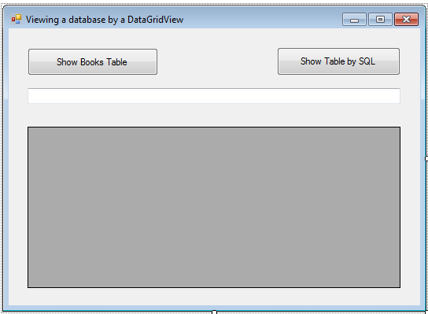

Properties Table

Object | Property | Setting
Form | Name  Text | Form3  Viewing a database by a DataGridView
Button | Name  Text | btnShowBook  Show Books Table
Button | Name  Text | btnSQL  Show Table by SQL
Text Box | Name | txtSQL
DataGridView | Name | dgvDisplay

Hint : After a data table has been filled, the statement
dgvDisplay.DataSource = dt
displays the contents of the data table dt in the data grid view.

- Add the following Imports statement in the code window of Form3

using System.Data.OleDb

- In the Declaration section of the Code window, declare two form variables connStr and sqlStr.

private string connStr = "Provider=Microsoft.ACE.OLEDB.12.0;"
+ "Data Source=lib.accdb";

- Add a procedure UpdateGrid

public void UpdateGrid(string sql) {
try {
DataTable dt = new DataTable();
OleDbDataAdapter dataAdapter =
new OleDbDataAdapter(sql, connStr);
dataAdapter.Fill(dt);
dataAdapter.Dispose();
dgvDisplay.DataSource = dt;
}
catch (Exception ex) {
MessageBox.Show(ex.Message);
}
}

- Use the following code in the Form Load event to fill dt with data from the database and display it in the DataGridView object dgvDisplay

private void Form3_Load(object sender, EventArgs e) {
UpdateGrid("Select * from Users");
}

- Run the program to see if the DataGridView displays the data of Users table correctly.

- Add code for the event btnShowBook_Click

private void btnShowBook_Click(object sender, EventArgs e) {
UpdateGrid("Select * from Books order by Author");
}

- Run the program and click on the Show Books Table button to see if the DataGridView displays correctly the data of Books table sorted in ascending order of the Author field.

- Add code for the event btnSQL_Click

private void btnSQL_Click(object sender, EventArgs e) {
UpdateGrid(txtSQL.Text);
}

- Run the program by inputting “Select * from Books order by Author DESC” in the text box and then clicking on the Show Table by SQL button.

- Try to input the following SQL statements and click on the Show Table by SQL button to see the results

SELECT * FROM BorrowRecords

SELECT * FROM BorrowRecords WHERE Username = ‘test1’

SELECT Users.FullName, BorrowRecords.BookID, BorrowRecords.BorrowDate, BorrowRecords.DueDate FROM Users INNER JOIN BorrowRecords ON Users.Username=BorrowRecords.Username

SELECT Title, Status, BorrowDate, DueDate FROM Books INNER JOIN BorrowRecords ON Books.BookID=BorrowRecords.BookID

